ALL OUTPUTS OF WEEK 1 ASSIGNMENT:-

1. Create a webpage with a title, a main heading, and two paragraphs.

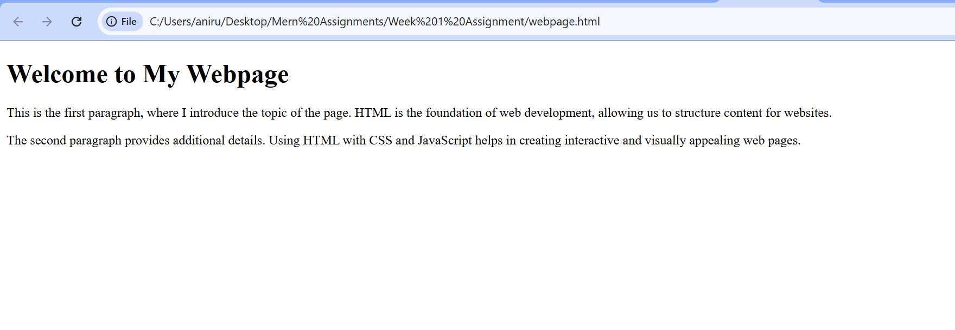

1. Add an image with a caption below it and center both on the page.

1. Style all paragraphs with a different font family, line height, and text alignment.

1. Design a styled button with padding, border, and a hover effect.

1. Create a simple table with three columns and three rows, and a basic form with two input fields and a submit buttonA screenshot of a form

   AI-generated content may be incorrect.